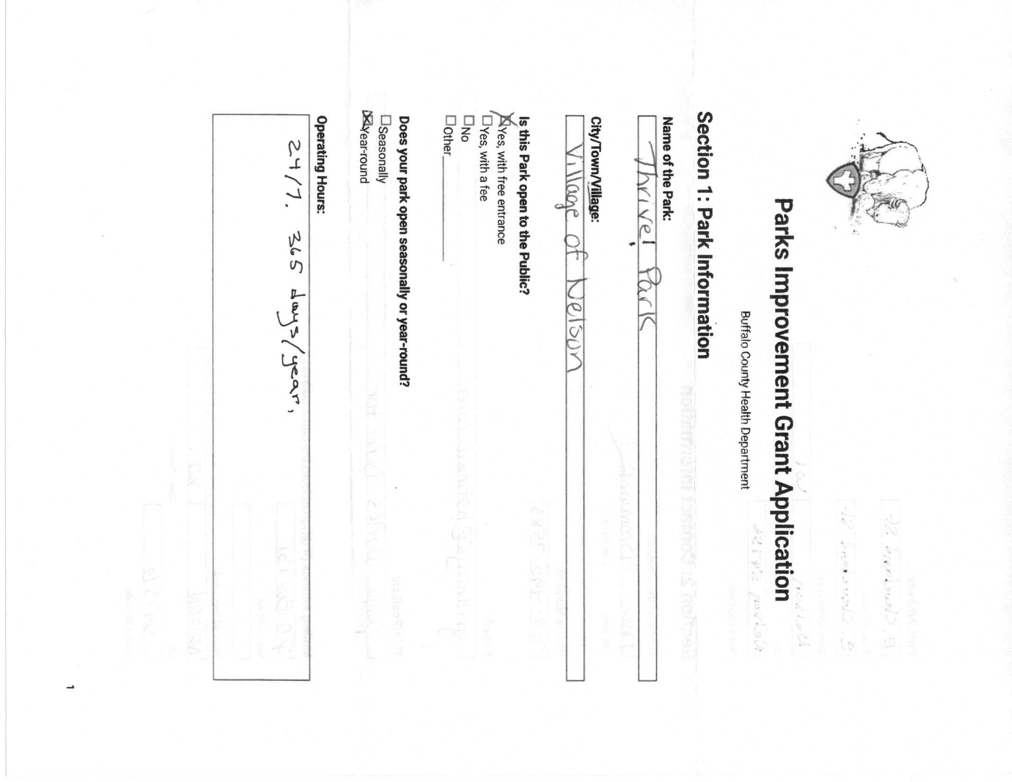

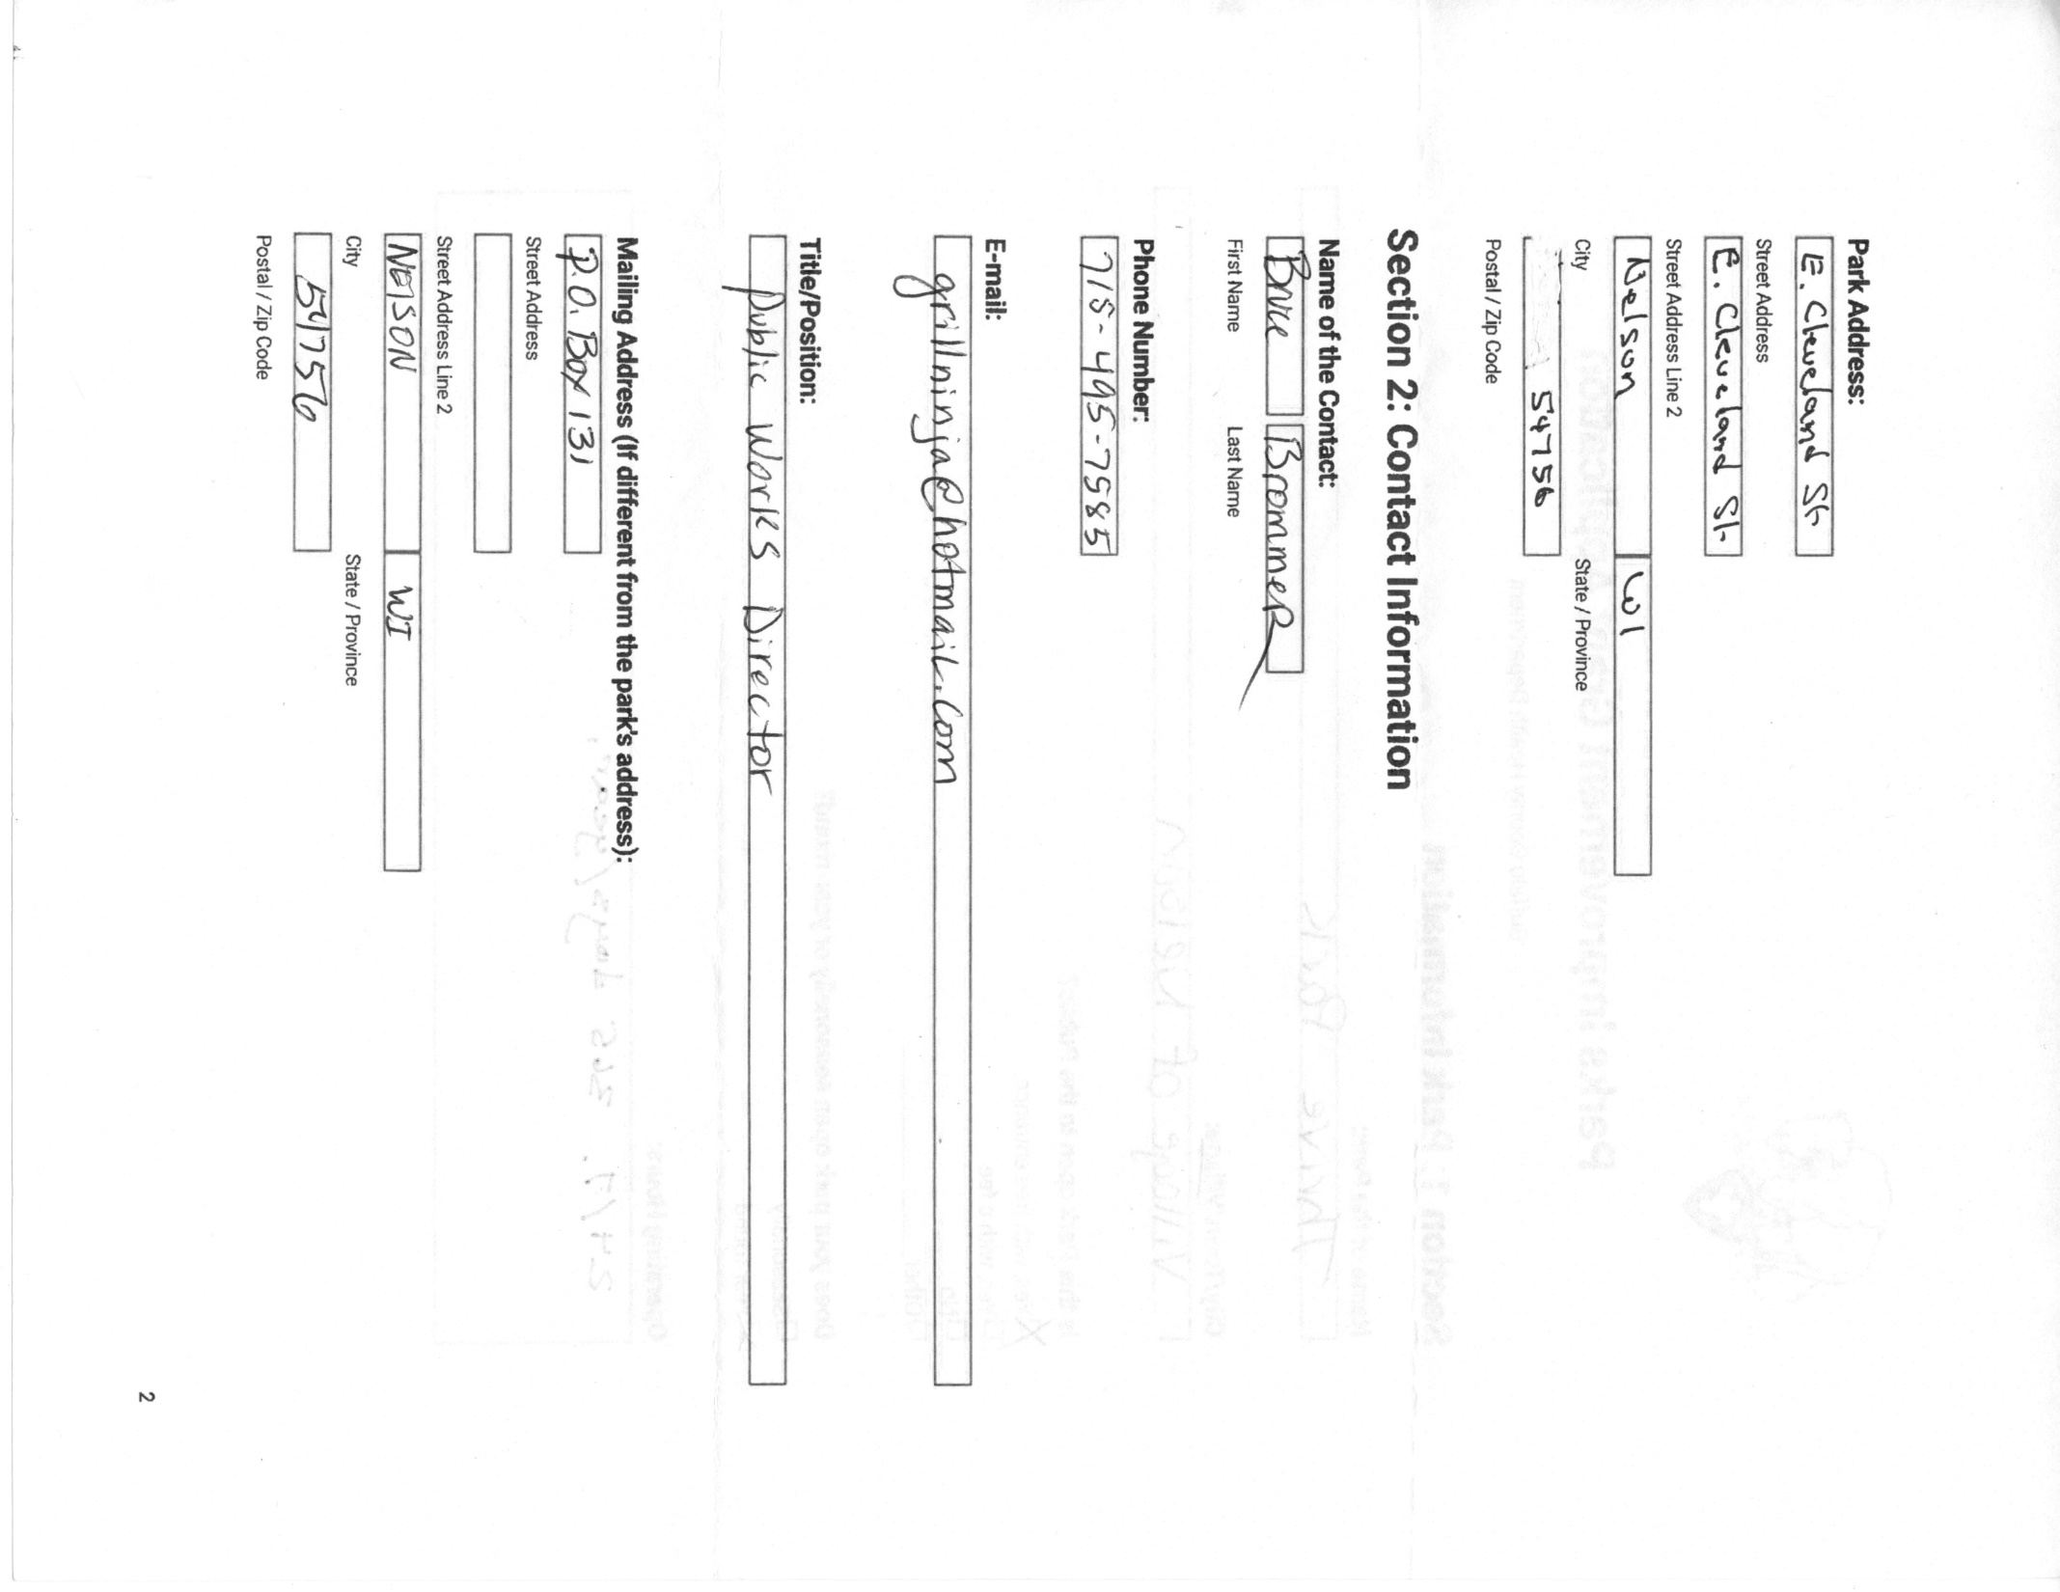
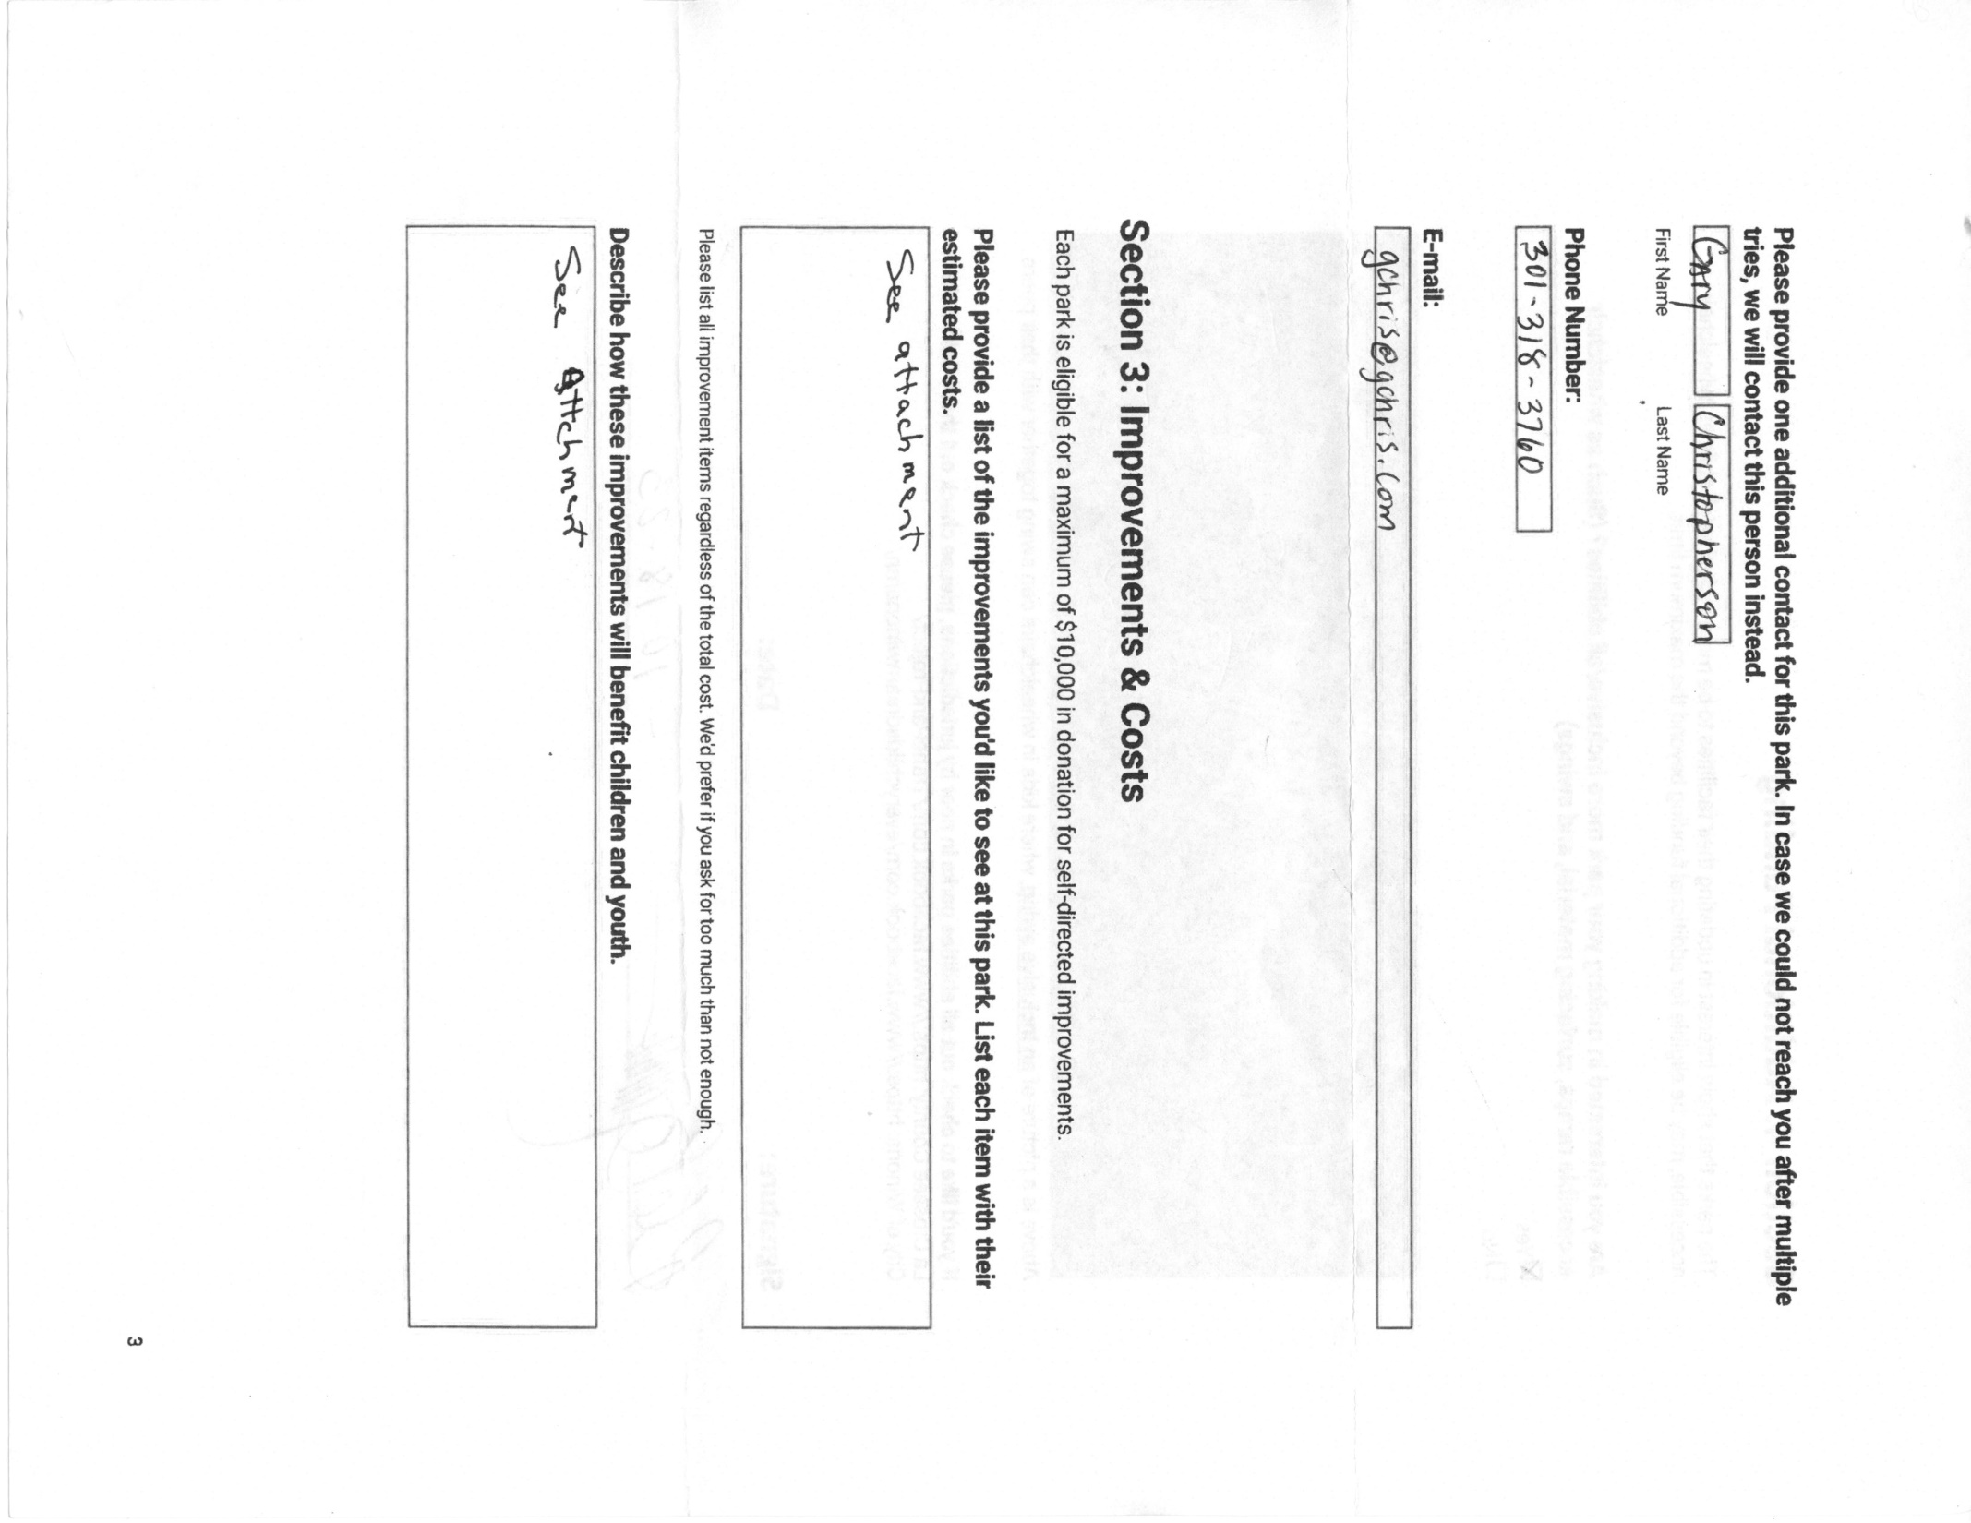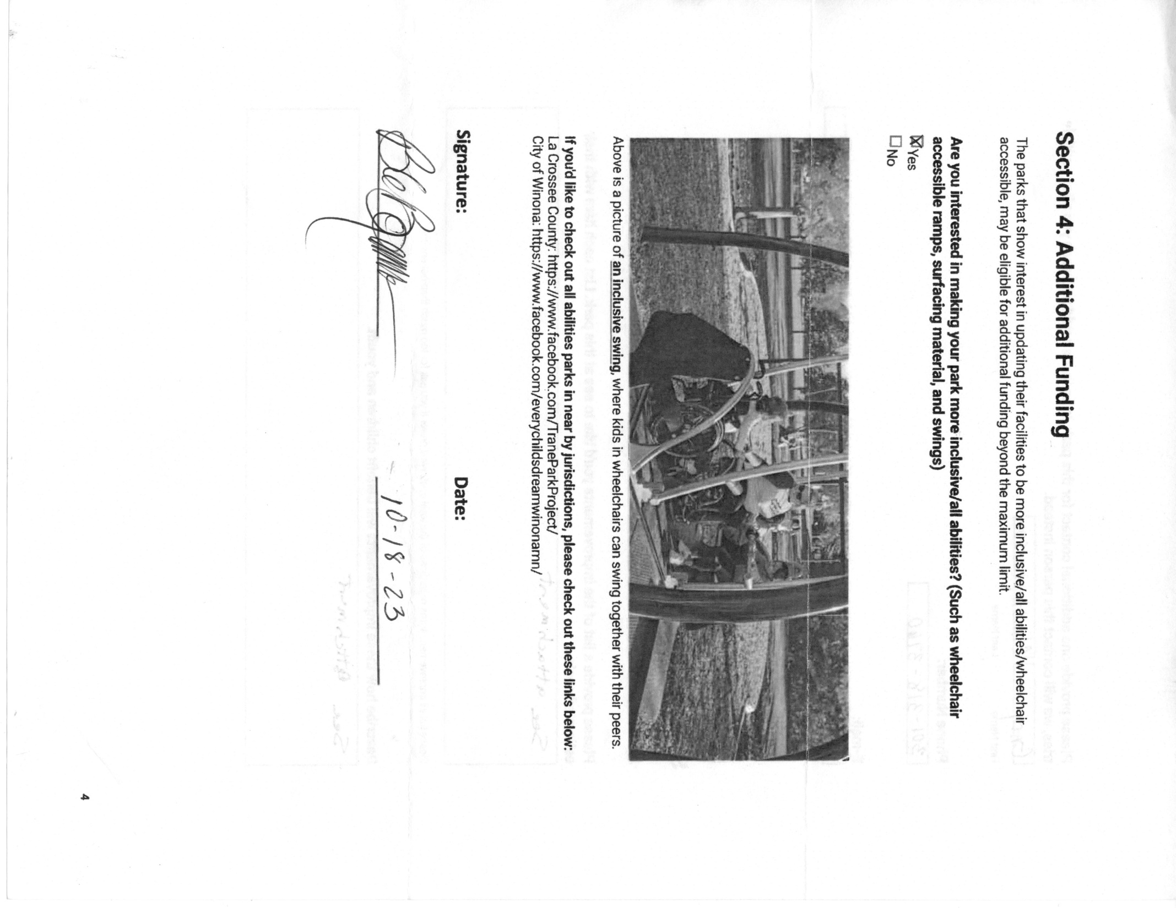

Subject: Proposed grant for Thrive! Park from Buffalo County – Improvements and Costs
Section 3: Improvements and Costs

Please provide a list of the improvements you’d like to see at this park (Thrive! Park!). List each with their estimated costs.
As you know, Thrive! Park was created and donated by Gary “Chris” Christopherson. Thrive! Park is now part of the Village of Nelson. The Park is a public park open to all at no cost. The Park has miles of trails from fairly easy lower trails to the more challenging upper trails to the two bluff tops and prairies.
Making sure that we are supporting the grant’s intent and vision, we are suggesting the following upgrades to improve physical access within Thrive! Park. Here is what we propose:
Improvement one: Building on a recent improvement of access to the Fish and Frog pond, we propose extending the current dirt trail to reduce the slope from the parking area up to the rim of the pond. Further, we propose to add a set of stairs that would give easier physical access to the top of the pond. If we can find a way to give full wheelchair access from the parking area up to the top of the pond, we propose to make that upgrade, if the funding allows.
Improvement two: We propose changing the lower entrance to the park to make it more physically accessible. That improvement would change the primary lower entrance to the old road going up into the park which is less of a slope. From there, we propose creating a dirt switchback trail that would be less of a slope and would connect with the Valley Hiking Road in the Park. If we can find a way to give handicap access up that road using ATV, UTV or golf cart for handicap access, we propose to make that upgrade if funding and the terrain allows.
Improvement three: We propose upgrading the Valley Hiking Road to make it more physically accessible. This would connect with the upgraded entrance from the lower parking area and from Gary “Chris” Christopherson’s hiking road. This latter road has been made available by Chris and, in the future, is planned to be donated to Thrive! Park. The upgrade would smooth the Valley Hiking Road surface, reduce the ups and downs of the road, and make it easier to maintain so as to be more physically accessible. If we can find a way to give full wheelchair access on the Valley Hiking Road (still would be a dirt hiking road), we propose to make that upgrade, if the funding allows.
Based on the best judgment of Public Works Director Bruce Brommer and Park Creator and Donor, we believe that all three of the above improvements can be accomplished within the $10,000 grant. We also believe it will take the full amount to make the above improvements. We have not broken out the cost per improvement as they are all linked and would likely be done by the same contractor.
Describe how these improvements will benefit children and youth.
Thrive! Park is visited by children and youth of all ages and including those with differing abilities and disabilities. The Park is visited by children and youth with mental and physical disabilities, including the develop disabilities. For those with limited mobility, accessing a bluffside park is always a bit more challenging. These improvements will greatly improve physical accessibility and allow visitors to access the park generally and to access more of the park trails, including picnic tables and benches.
Improvement one: Younger visitors are especially drawn to the Fish and Frog Pond. The more accessible trail will help those with limited mobility (including those with a disability and those who are very young) get up to and better enjoy the frogs and fish and the calming ravine surrounding the Frog and Fish Pond.
Improvement two: Currently, the lower entrance to Thrive! Park is a very steep hike to get up on the main trails, including the Valley Hiking Road. Softening the slope (using a switchback trail) from the lower entrance up to the Valley Hiking Road will give children and youth with limited mobility (those with disabilities and those who are very young) the opportunity to get up to the Valley Hiking Road, a key access road to all the Park’s trails.
Improvement three: Currently, the Valley Hiking Road has a number of ups and downs that make it more difficult for those with limited mobility and those who are very young. Smoothing out the Hiking Road from beginning to end will allow much easier access. Less slope. Less up and down. A wider (5-6’) hiking road. A smooth dirt surface. It will also help with keeping the Hiking Road free from weeds as it will be movable end to end.

Section 4: Additional Funding
As we indicated with the above three improvements, we are very interested in making Thrive! Park more inclusive of all abilities. We would like very much to discuss what more we can do to be even more inclusive. We have already addressed surface improvements and reducing slope in our three proposed improvements. We would like to go further and would like to sit down with you on what might be the best way to further improve accessibility for those with limited mobility. This could be a unique opportunity to be more inclusive of all abilities in a bluffside hiking park, an environment very different that the usual, relatively flat urban park. It would require some very creative thinking about how to accomplish more inclusiveness in this environment.

